* The command to bootstrap the network:

1. Command to generate the crypto-materials:

./fabricNetwork.sh generate

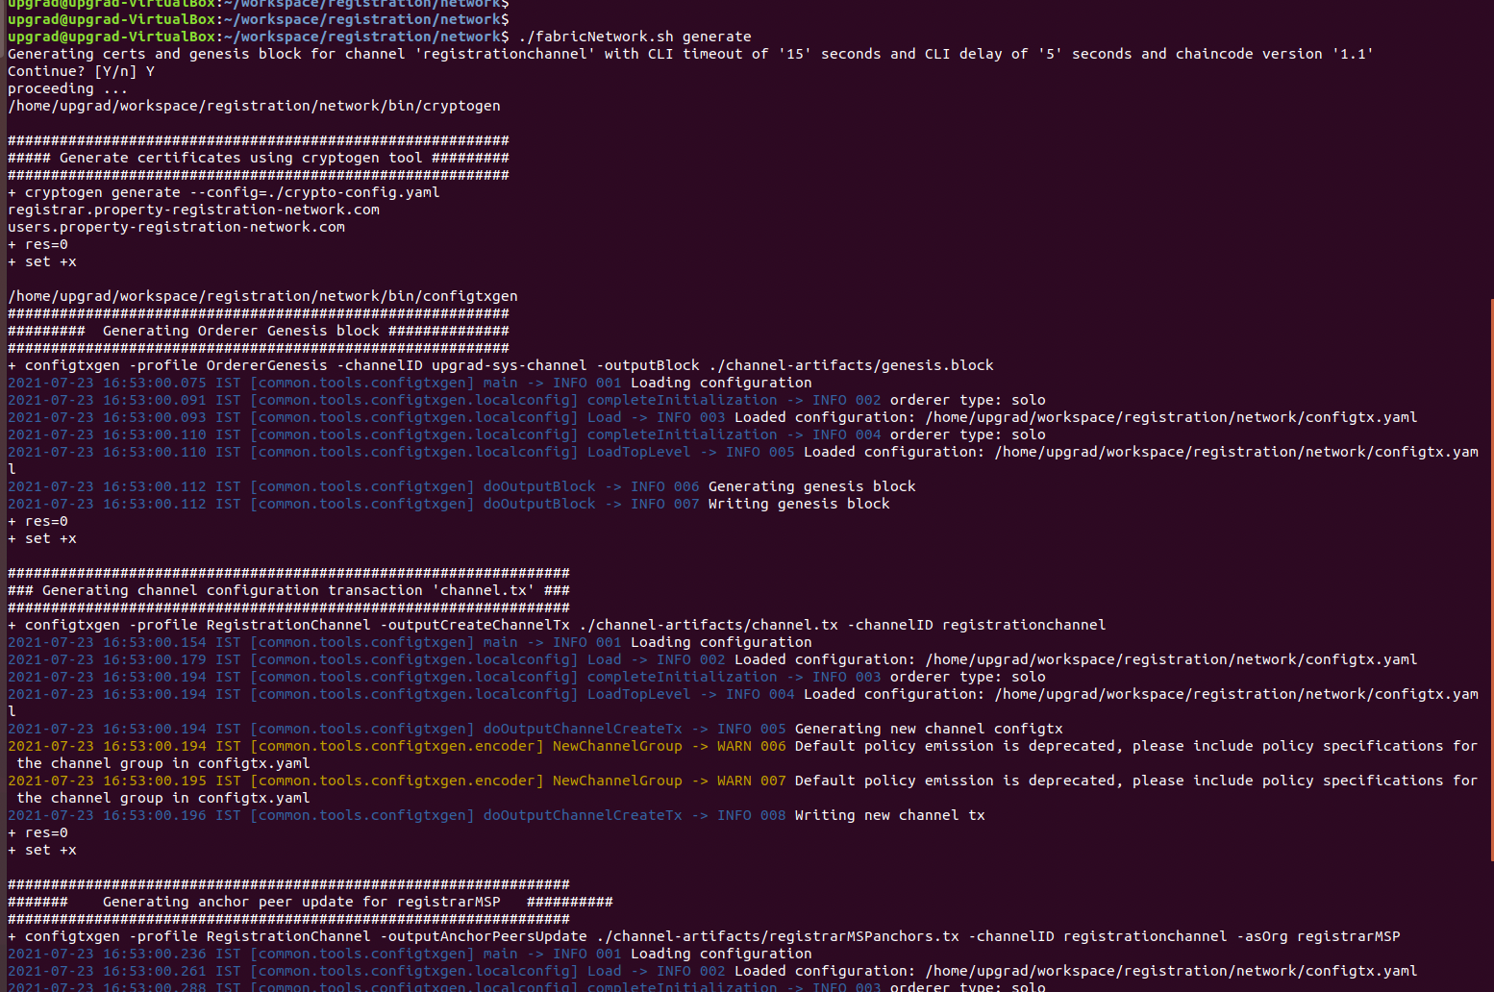

2. Command to start the network

./fabricNetwork.sh up

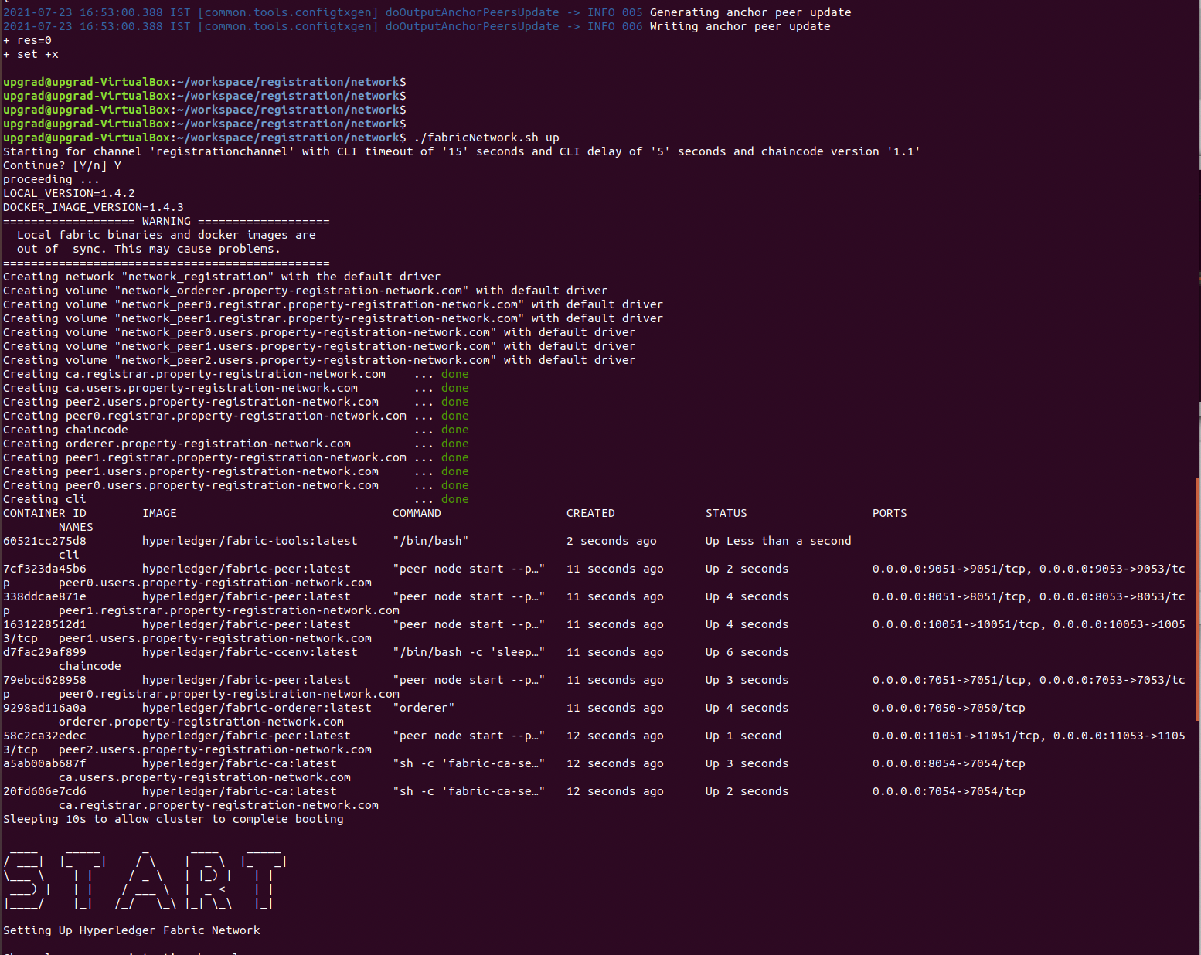

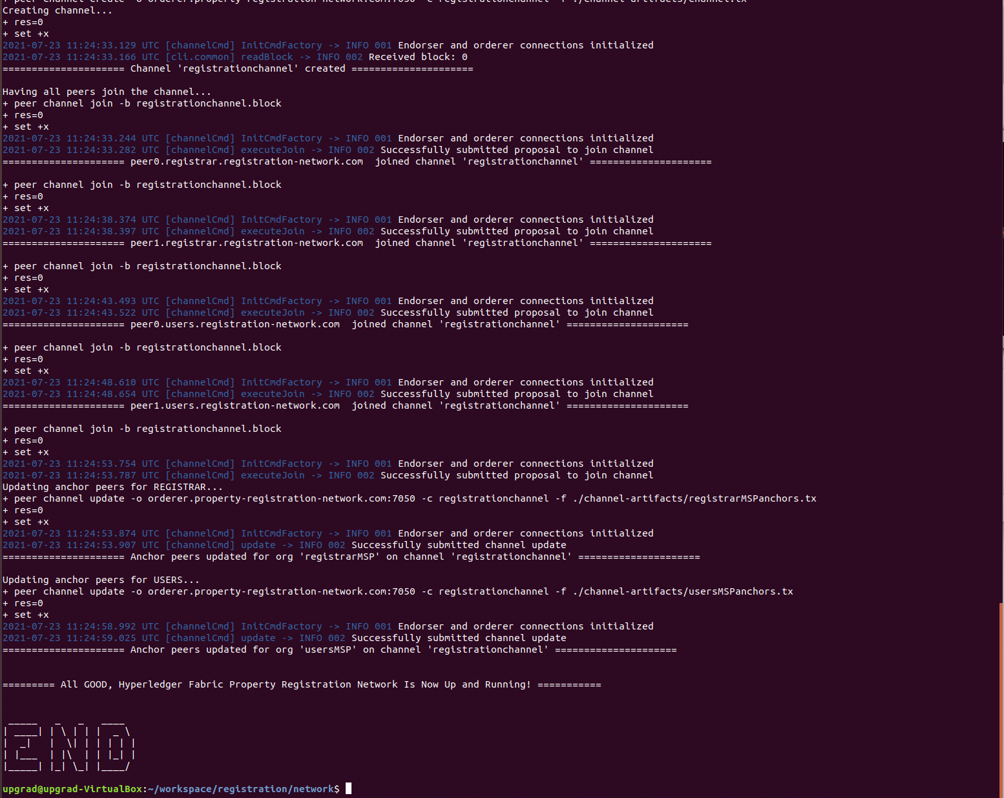

All are Up:

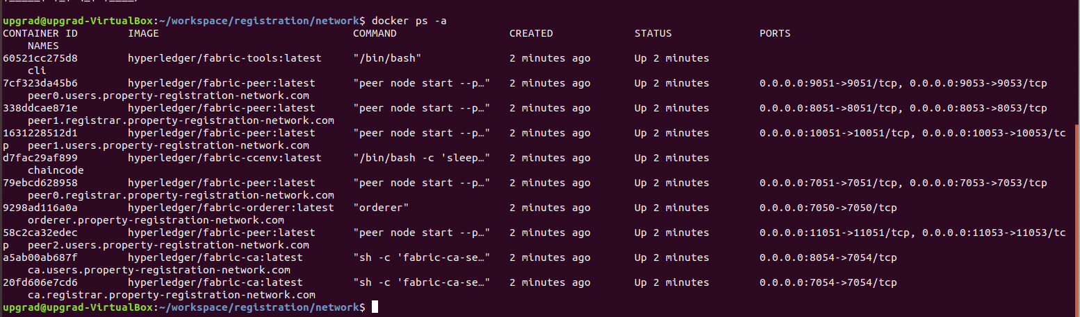

3. Command to kill the network

./fabricNetwork.sh down

4. Start the chaincode

1> docker exec -it /bin/bash

Npm install

Npm run start-dev

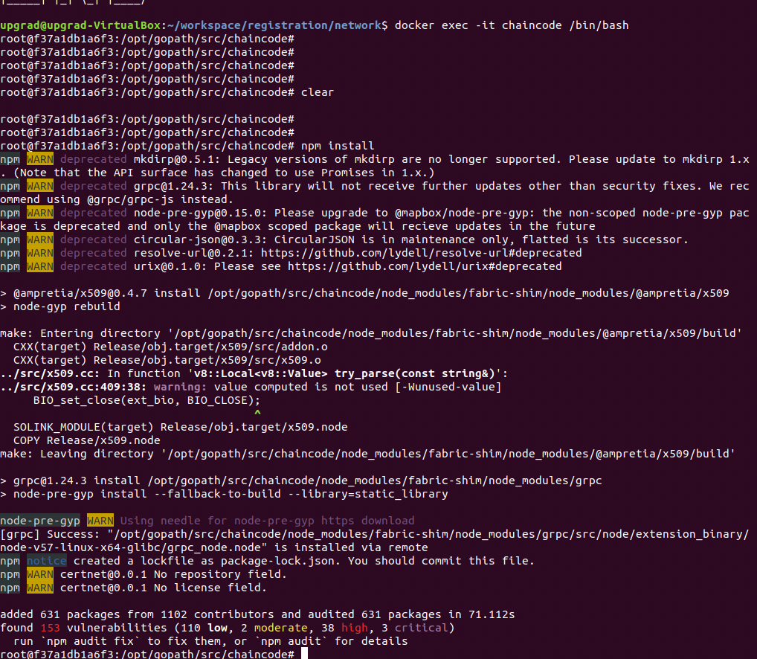

* 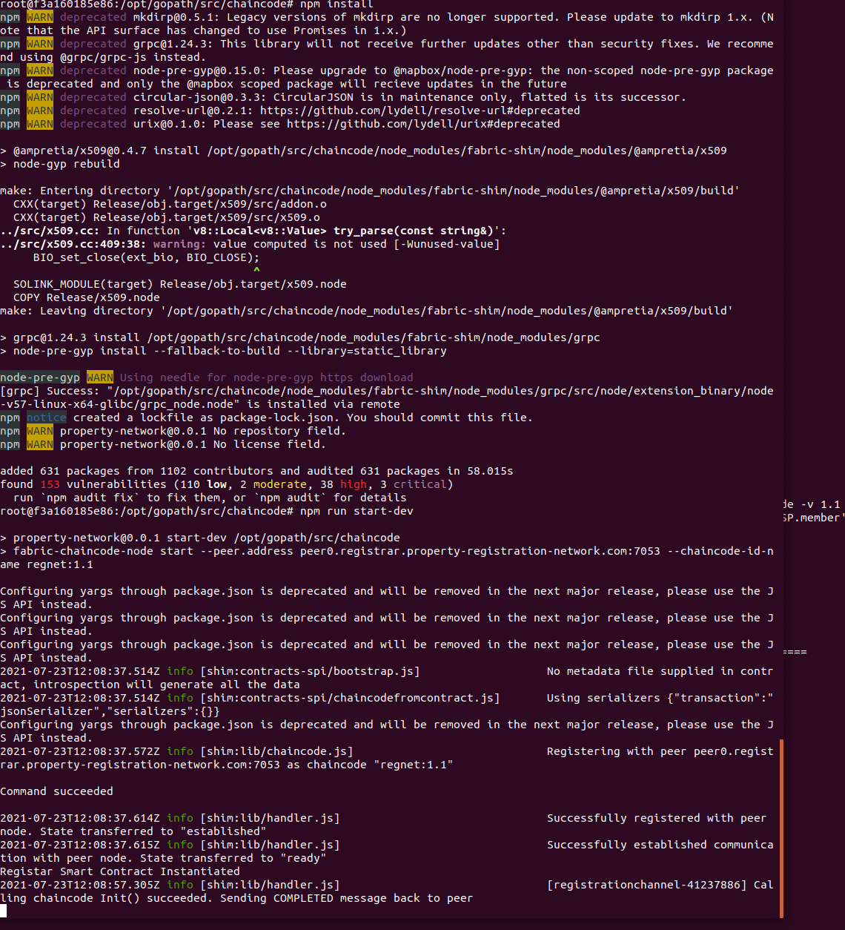The command to install and instantiate the chaincode:

Command to install and instantiate the chaincode on the network

./fabricNetwork.sh install

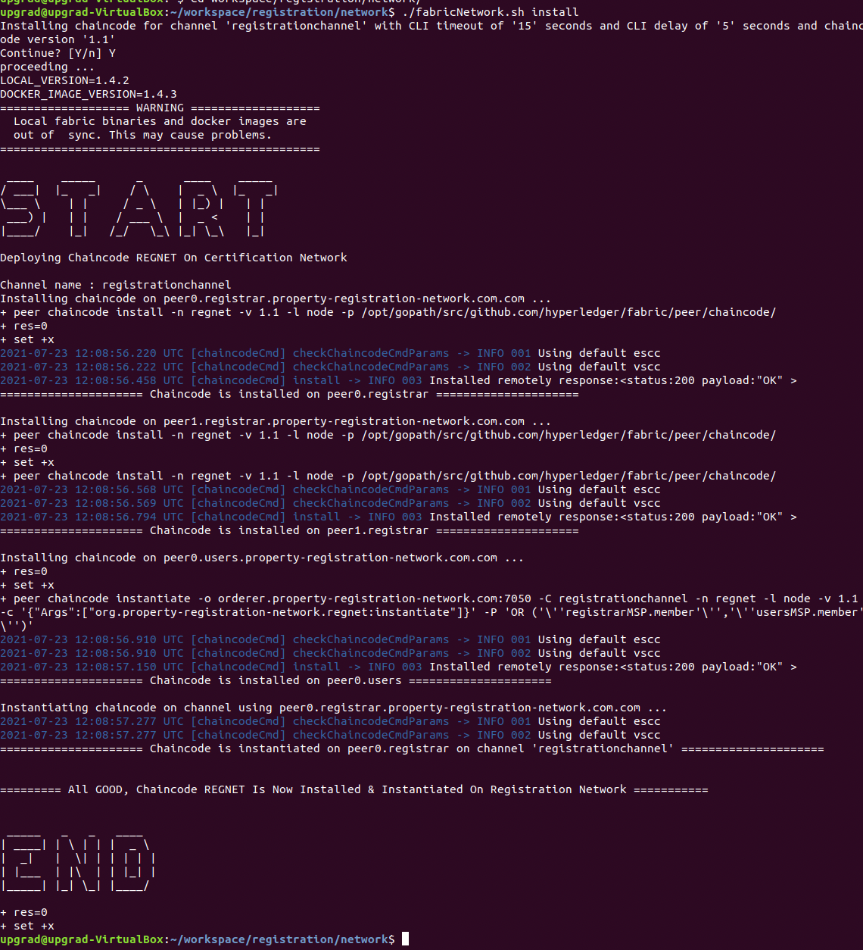

* The commands to execute each of the transactions defined in the chaincode in sequential order and

Open CLI terminal

One connected to Registrar:

Docker exec -it cli /bin/bash

By Default ENV ARE SET to registrar

Another connected to User :

SSH to clicontainer in new terminal/tabusing the following command

docker exec -it cli /bin/bash

Set ENV variables to connect to User’s Node

export CORE_PEER_LOCALMSPID=usersMSPexport CORE_PEER_ADDRESS=peer0.users.property-registration-network.com:9051export CORE_PEER_MSPCONFIGPATH=/opt/gopath/src/github.com/hyperledger/fabric/peer/crypto/peerOrganizations/users.property-registration-network.com/users/Admin@users.property-registration-network.com/msp

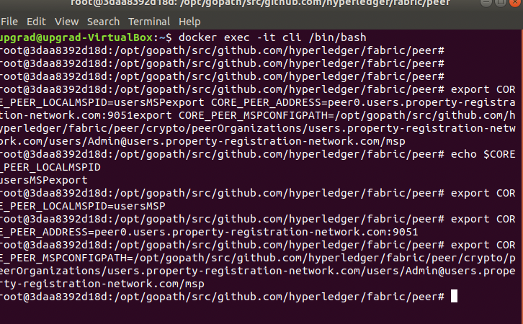

* Verify the chaincode logic:
* **RegisterNewUser:**

Run from User terminal

* + peer chaincode invoke -o orderer.property-registration-network.com:7050 -C registrationchannel -n regnet -c '{"Args":["org.property-registration-network.regnet.usercontract:requestNewUser","Deepika","deep @gmail.com","9970045873","0000-0000-1234"]}'

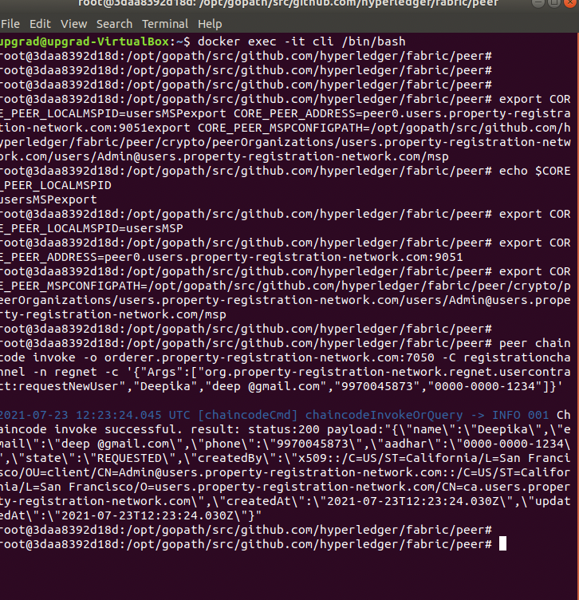

* **approveNewUser**

Run from Registrar CLI

peer chaincode invoke -o orderer.property-registration-network.com:7050 -C registrationchannel -n regnet -c '{"Args":["org.property-registration-network.regnet:approveNewUser","Deepika","0000-0000-1234"]}'

peer chaincode invoke -o orderer.property-registration-network.com:7050 -C registrationchannel -n regnet -c '{"Args":["org.property-registration-network.regnet:approveNewUser","Prachi","0000-0000-1111"]}'

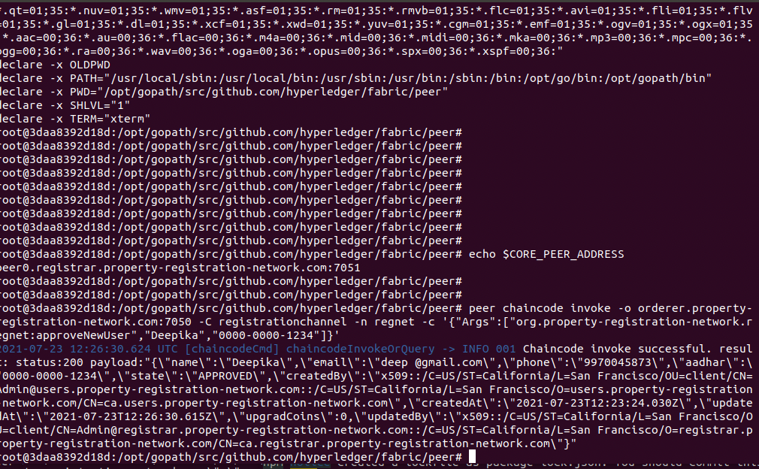

**Invalid User Validation**

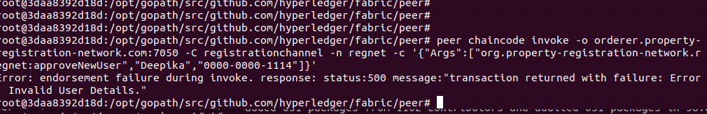

* **rechargeAccount**

**From** User terminal

Recharge valid user & invalid user

peer chaincode invoke -o orderer.property-registration-network.com:7050 -C registrationchannel -n regnet -c '{"Args":["org.property-registration-network.regnet.usercontract:rechargeUserAccount","Deepika","0000-0000-1234","upg1000"]}'

peer chaincode invoke -o orderer.property-registration-network.com:7050 -C registrationchannel -n regnet -c '{"Args":["org.property-registration-network.regnet.usercontract:rechargeUserAccount","Prachi","0000-0000-1111","upg1000"]}’

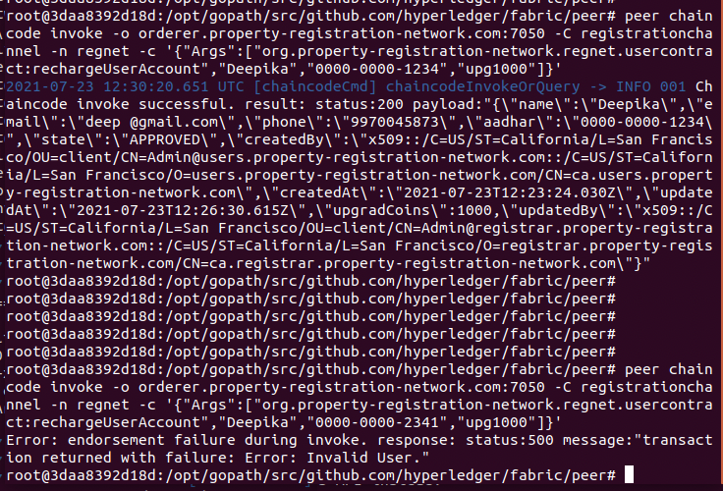

* ViewUser

From both terminal valid & invalid user

peer chaincode invoke -o orderer.property-registration-network.com:7050 -C registrationchannel -n regnet -c '{"Args":["org.property-registration-network.regnet.usercontract:viewUser","Deepika","0000-0000-1234"]}'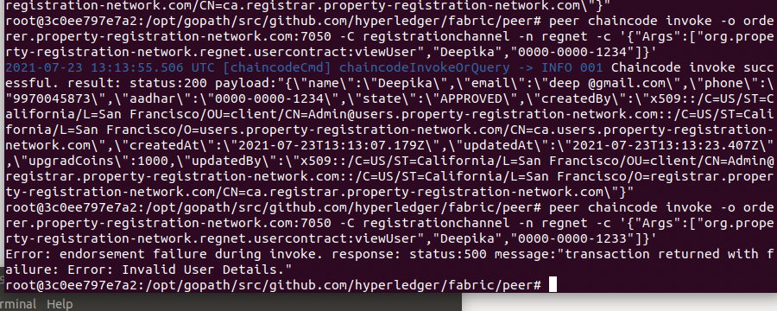

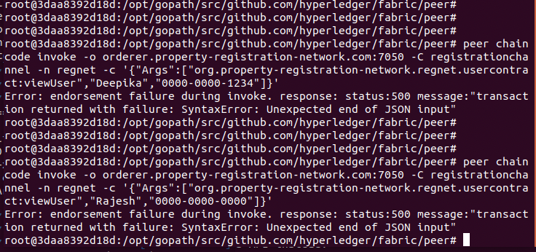

**propertyRegistrationRequest:**

peer chaincode invoke -o orderer.property-registration-network.com:7050 -C registrationchannel -n regnet -c '{"Args":["org.property-registration-network.regnet.usercontract:propertyRegistrationRequest","1","500","REQUSET","Deepika","0000-0000-1234"]}'

**approvePropertyRegistration:**

**from registrar terminal**

peer chaincode invoke -o orderer.property-registration-network.com:7050 -C registrationchannel -n regnet -c '{"Args":["org.property-registration-network.regnet:approvePropertyRegistration","1"]}'

**view-property**

peer chaincode invoke -o orderer.property-registration-network.com:7050 -C registrationchannel -n regnet -c '{"Args":["org.property-registration-network.regnet:viewProperty","1"]}'

**updateProperty:**

peer chaincode invoke -o orderer.property-registration-network.com:7050 -C registrationchannel -n regnet -c '{"Args":["org.property-registration-network.regnet.usercontract:updateProperty","1","onSale","Rajesh","0000-0000-0000"]}'

**purchaseproperty:**

**/* Prachi new user created and recharged */**

peer chaincode invoke -o orderer.property-registration-network.com:7050 -C registrationchannel -n regnet -c '{"Args":["org.property-registration-network.regnet.usercontract:purchaseProperty","1","Prachi","0000-0000-1111"]}'